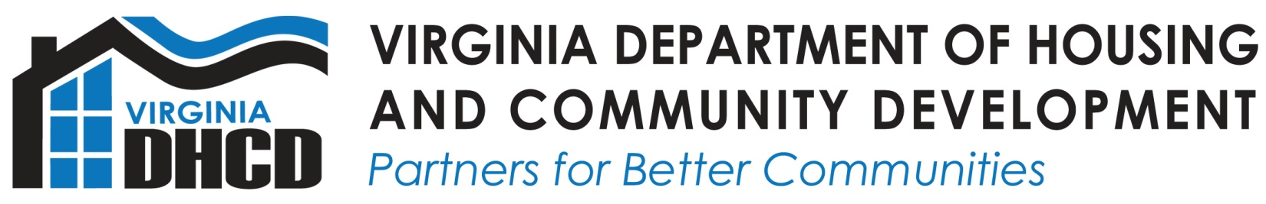
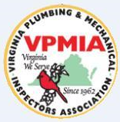
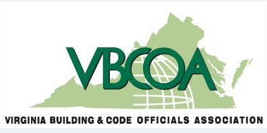

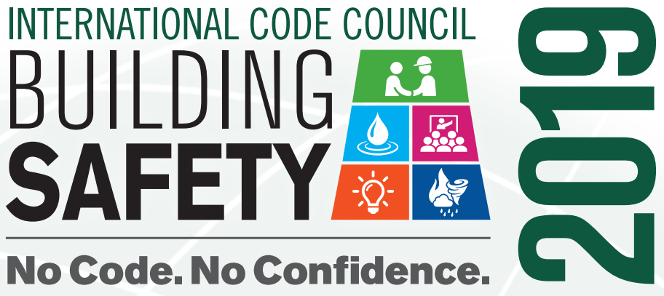
2019 Student Scholarship Opportunity
No Code. No Confidence.
Introduction
The Virginia Department of Housing and Community Development (DHCD), the Virginia Building and Code Officials Association (VBCOA), and the Virginia Plumbing and Mechanical Inspectors Association (VPMIA) have partenered to offer student scholarships in support of Building Safety Month. There will be a total of five secondary or higher education scholarships to rising or graduating high school seniors and current first, second or third year students of a two or four year institution. Interested applicants are invited to submit a 1000-word or less essay that illustrates how building codes in a community contributes to the confidence within the community.

Scholarships will be awarded in the following manner:
First Place $2000
Second Place $1000
3 Honorable mentions of $500 each

Essay Prompt

The International Code Council (ICC) www.iccsafe.org is a member-focused association dedicated to developing model codes and standards used in the design, build, and compliance process to construct safe, sustainable, affordable, and resilient structures. Every May ICC promotes an awareness campaign called Building Safety Month https://www.iccsafe.org/about-icc/building-safety-month/2019-building-safety-month/ to help individuals, families, and businesses understand what it takes to create safe and sustainable structures. Building Safety Month highlights the ways communities and its citizens can stay safe in the buildings that they live, school, work, and play in. It also brings attention to the important work of the code official whose job it is to ensure that all buildings are constructed safely and how building departments are a resource for everyone; from the professional contractor to the weekend DIYer.

This May, the Building Safety Month theme is ‘No Code. No Confidence’. There are many building codes that are in place within our communities. We maneuver through our lives each day without giving much thought as to how our neighborhoods are protected because of those building codes. Reflect on the venues that you frequent and how confident you are that the buildings, homes and arenas are built safely.

In 1000 words or less answer the following question:
How does having building codes in place increase the level of confidence within a community?
Scholarship Rules
- This scholarship is open to residents of the Commonwealth of Virginia only. Entrants must be a current junior or graduating high school senior within Virginia public schools, Virginia private schools, or those that are Virginia home schooled. In addition, this scholarship is open to those students who will be enrolled in a two or four higher education institution this coming fall semester.
- All submissions become the property of the Department of Housing and Community Development and will not be returned.
- All entries must be original work and not previously published.
- Essays must be 1,000 words or less, clearly labeled with entrant’s name, home address, phone number, and email address as well as the name, address, and phone number of the high school or higher education institution in the upper right hand corner of the submission. Each page should be numbered in the lower left hand corner.
- The Essay Application must be completed and attached to all essay submissions.
- All submissions should be typed and submitted via email (preferred) or by US mail to:
VA Department of Housing and Community Development
Building Code Safety Month Essay Contest
Attn: Rishaunda Robinson
600 East Main Street, Suite 300
Richmond, VA 23219
Rishaunda.Robinson@dhcd.virginia.gov

- All entries must be received no later than 11:59 p.m. on May 12, 2019.
- DHCD has the right to edit and publish entries as deemed fit both in print and on the Web.
- The scholarship recipient, and his or her parent(s) or legal guardian agree to the use of the recipient’s name and entry in any form for publicity or trade purposes by DHCD, VBCOA, or VPMIA without additional compensation.
- No substitutions of the stated scholarship will be offered.
- Family members of DHCD employees are not eligible to participate.
- Scholarship recipients will be announced no later than May 24, 2019; winners will be contacted by email or phone.
- Winners must complete a W-9 prior to award issuance.
- The award amount will be sent directly to the scholarship recipient.

Selection Criteria

- All entries must be original work and not previously published.
- All entries will be judged equally on the basis of merit by a selection committee that will look for:
  - Content and understanding of essay’s theme
  - Originality
  - Clear reasoning
  - Grammer and punctionality
- Student status will be verified prior to award issuance.
- Selection Committee decisions are final.

